Body Weight Workouts
 |  |  | 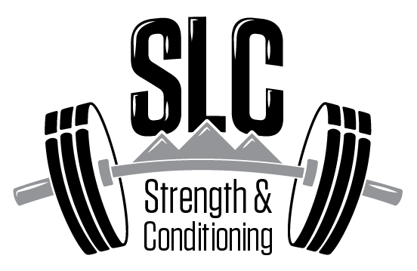
 |  | Day 1
Day #1
 | Warm up | Speed Mechanics-HIGH KNEES, BUTT KICKS, A-SKIP
 |  | Core-Front Plank 2X1 min
 |  | Workout
 |  | Warm up (specifics) | Sets/Reps | Weight | rest
 |  | Bird Dogs | 2X24 (12/12)
 | Levels | Giant Set | Sets/Reps | Weight | rest
 |  | Body Weigth Squats | 4X15 | BW
 |  | Sgl Leg Glute Bridges | 4X15/15 | BW
 |  | Straight Leg lifts | 4X15 | BW | 30 sec
 |  | Giant Set | Sets/Reps | Weight/% | rest
 |  | Push ups | 3X12 | BW
 |  | Scap Push ups | 3X12 | BW
 |  | T-s | 3X12 | BW
 |  | Arms | Sets/Reps | Weight/% | rest
 |  | Sgl leg RDL Hold | 3X30/30 | 10-30 lbs
 |  | Side Lunges | 3X12/12 | 10-20 lbs
 |  | Cardio | Sets/Reps | Weight/% | rest
 |  | Light Run | 10 minutes or 1.5 miles
 |  | Recovery
 |  | Static Stretch-Hamstrings/Hips/Quads

